1. Demonstrate Creation of an Action Method to Return a List of Custom Class Entity
A custom class entity is a model class that represents data, such as Student, Employee, or Product. An Action Method inside a controller returns a list of these objects to the client.
Example: A StudentController can return a list of Student objects when a GET request is made.
Steps:
1. Create a model class (Student.cs).
2. Create a controller.
3. Use the [HttpGet] attribute.
4. Return a List<Student>.

2. What is a Model Class?
A Model Class is a C# class that represents the data used by the application. It contains properties that match the information stored in the database or sent by the client.
Example:
Student -> Id, Name, Branch.

3. What is the AllowAnonymous Attribute?
The [AllowAnonymous] attribute allows anyone to access an API method without logging in or providing authentication.
It is mainly used for public APIs such as Login, Register, or Public Information pages.

4. What is the HttpGet Attribute?
The [HttpGet] attribute tells the Web API that the action method should respond only to HTTP GET requests. It is mainly used to read or retrieve data from the server.

5. Explain the Usage of FromBody Attribute
The [FromBody] attribute tells ASP.NET Core to read the data from the request body instead of the URL or query string.
It is mostly used with POST and PUT requests when sending JSON data.
Example: If a client sends a Student object in JSON format, [FromBody] converts that JSON into a Student object automatically.

6. What is a Custom Filter?
A Custom Filter is a class that allows us to execute code before or after an action method runs. It is used for logging, validation, authentication, and exception handling without writing the same code in every action.

7. Usage of ActionFilterAttribute
ActionFilterAttribute is the base class used to create custom action filters. By inheriting from this class, we can intercept requests before and after an action method executes.

8. Explain OnActionExecuting Method
OnActionExecuting() is a method inside ActionFilterAttribute. It runs before the action method starts executing.
It is commonly used to validate input, check headers, log requests, or stop invalid requests before reaching the action method.

9. Custom Exception Filter
A Custom Exception Filter is used to handle application exceptions in one place. Instead of writing try-catch blocks in every action method, exceptions can be handled using a custom filter, making the code cleaner and easier to maintain.

10. Microsoft.AspNetCore.Mvc.WebApiCompatShim Package
This NuGet package provides compatibility features for older ASP.NET Web API applications when migrating to ASP.NET Core. It is required in some projects to use Web API compatibility features while creating custom filters and older Web API components.
- Web Api using custom model class
Create a Custom class ‘Employee’ of the below defined structure
public class Employee
{
public int Id { get; set; }
public string Name { get; set; }
public int Salary { get; set; }
public bool Permanent { get; set; }
public Department Department { get; set; }
public List<Skill> Skills { get; set; }
public DateTime DateOfBirth { get; set; }
}

Create a new controller - EmployeeController with Read Write actions
Constructor: Create few records, HTTPGet, HTTPPost/HTTPPut
Create a Private method GetStandardEmployeeList that returns a List of Employee class. Invoke this method in the Get action method of the EmployeeController that was created in the previous step.
Public ActionResult<Employee> GetStandrad()
Modify the return type of the Get action method(without parameter) to return List of Employee class object
Add ProducesResponseType to the GET action method for Status code 200
Check the Swagger description for the GET method for success status code

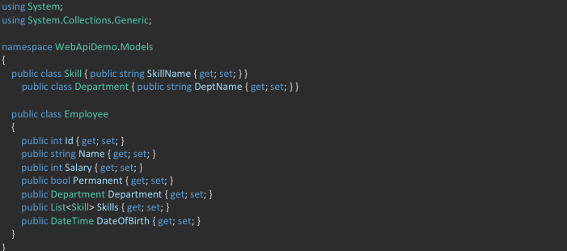
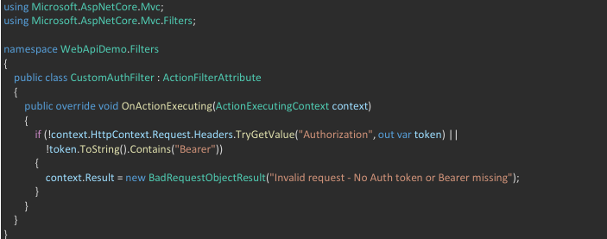
- Create a Custom action filter for Authorization.
The requirement is to intercept incoming requests and check if there is a key ‘Authorization’ in the request header or not. If it is there, then to check if it contains a value ‘Bearer’ or not.

Create a folder ‘Filters’ in the application solution. Create a class ‘CustomAuthFilter’ to filter requests. Inherit ActionFilterAttribute. Override OnActionExecuting method to check if the request object has Header ‘Authorization’ or not. If not, throw BadRequestResult with the message
Invalid request - No Auth token
If the header is present, then check if the value contains the word ‘Bearer’. If not, throw BadRequestResult with the message
Invalid request - Token present but Bearer unavailable

Add an attribute CustomAuthFilter to the Employee controller to filter any request to check for the Authorization token in the request header.

